**Day 6 Output:**

**Console:**

**Ratings are shown in the form of array here.**

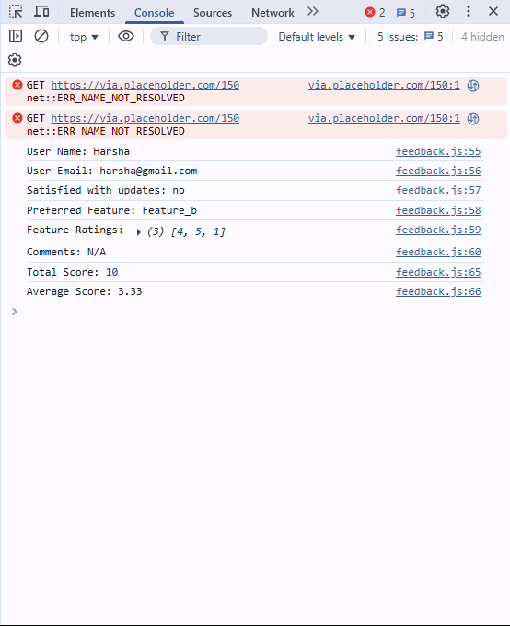

**Shows error if the name is not entered**

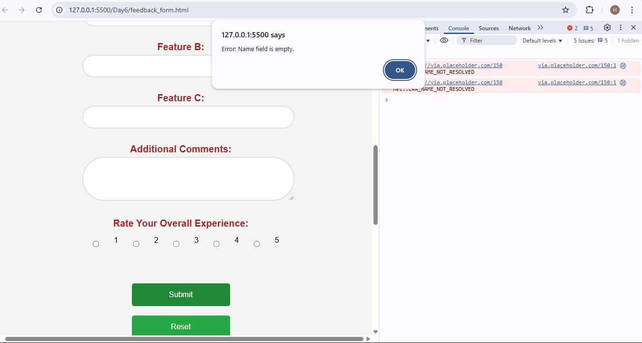

**Shows warning if the email is of wrong format**

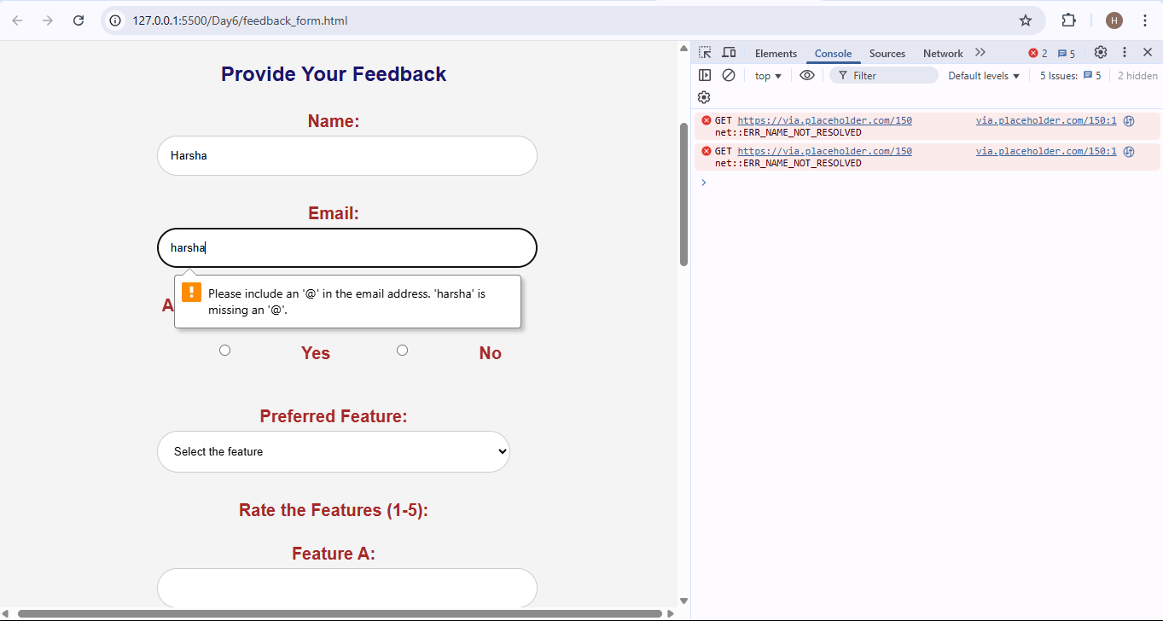

**Ensures that we need to select the satisfaction level (YES/NO).**

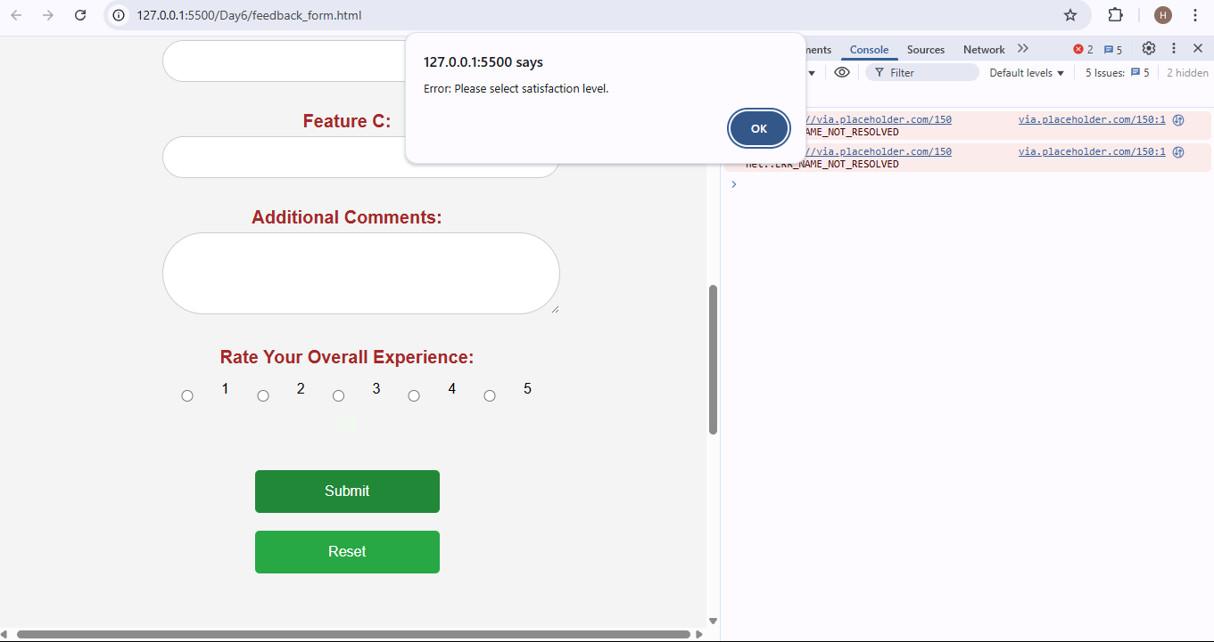

**Gives warning if we do not select a feature.**

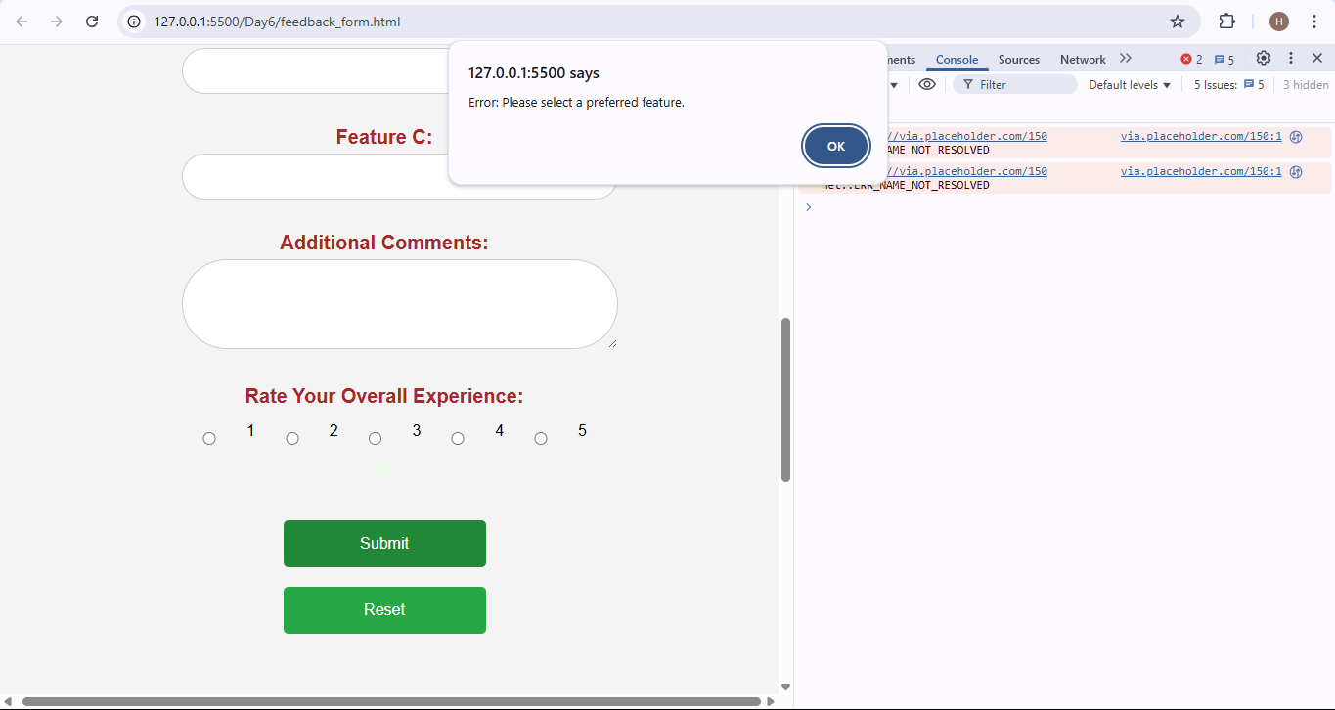

**Shows warning if we give rating more than 5**

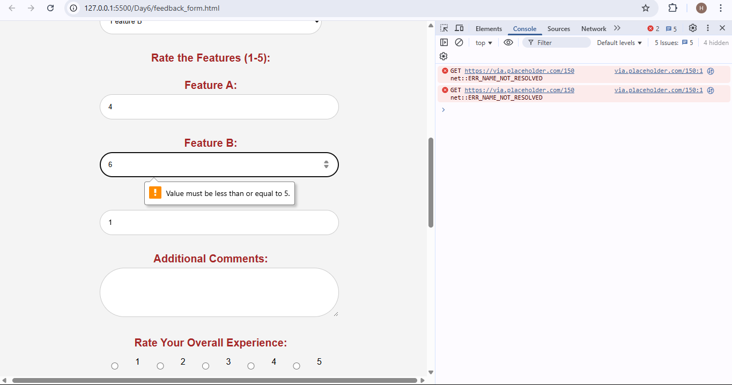

**Displays message if we rate them**

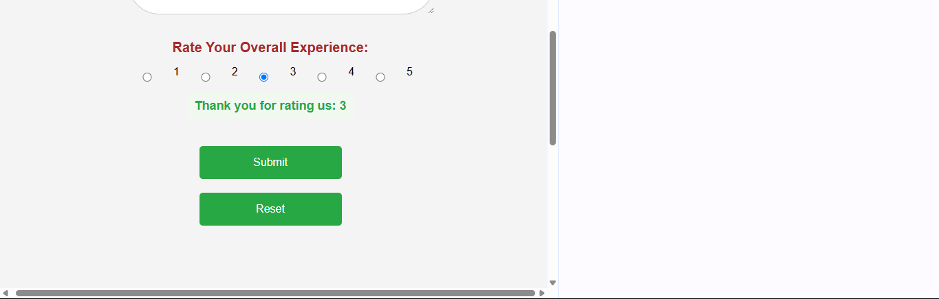

**Resets the page if we click the reset button.**

